# **F**inancial Risk Prediction using IBM Auto AI

# 1. INTRODUCTION

Automation and artiﬁcial intelligence (AI) aretransforming businesses and will contribute to economic growth via contributions to productivity. They will also help address challenges in areas of healthcare, technology & other areas. At the same time, these technologies will transform the nature of work and the workplace itself. In this code pattern, we will focus on building state of the art systems for churning out predictions which can be used in different scenarios. We will try to predict fraudulent transactions which we know can reduce monetary loss and risk mitigation. The same approach can be used for predicting customer churn, demand and supply forecast andothers. Building predictive models require time, effort and good knowledge of algorithms to create effective systems which can predict the outcome accurately. With that being said, IBM has introduced Auto AI which will automate all the tasks involved in building predictive models for different requirements. We will get to see how Auto AI can churn out great models quickly which will save time and effort and aid in faster decisionmaking process.

When the readerhas completed this code pattern, they will understand

how to :

* + Quickly set up the services on cloudfor model building.
  + Ingest the data and initiate the Auto AI process.
  + Builddifferent models using Auto AI and evaluatethe performance.
  + Choose the best model and complete the deployment.
  + Generate predictions using the deployed modelby making ReST calls.
  + Compare the process of using Auto AI and building the model manually.

# 2. LITERATURE SURVEY

We need to create the Necessary IBM services. The following are the servicesthat you have to create.

* + Watson studio
  + Node-RED
  + Cloud Object Storage service (COS)
  + Machine Learning service (ML)

COS and ML services will e created while creating a Watson StudioProject

# 3. THEORITICAL ANALYSIS:

**BLOCK DIAGRAM:**

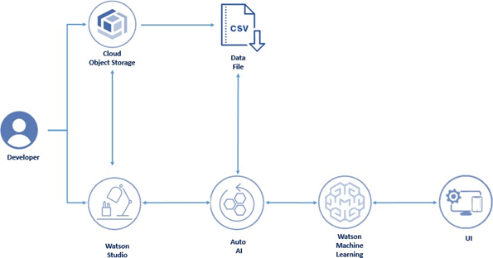

**Services Used:**

1. IBM Watson Studio
2. IBM Watson MachineLearning
3. Node-RED
4. IBM Cloud ObjectStorage

# 4. EXPERIMENTAL INVESTIGATIONS

The AutoAI experiment has been completed in 97 secondsto generate four pipelines.

The duration of experimentdepends completly on the size of the dataset. The duration of experimentdepends completly on the size of the dataset. . AutoAI selects the appropriate machine learning algorithm (in the ﬁfth stage of the process under Model Selection) which is best suited for the dataset.

Each pipeline is run with different parameters, pipeline 3 is run on a sequence of HPO (hyper parameters optimization) & FE (featureengineering) where as pipeline 4 includes HPO (hyper parameters optimization), FE (feature engineering) and a combination of both. All these are done on the ﬂy! Isn't it amazing that we just have to sit and watch while AutoAI takes care of things for us and generates awesome machine learning models!! There's very minimal intervention required to get things going and in no time we have the generatedpipelines to choose from.

# 5. FLOWCHART

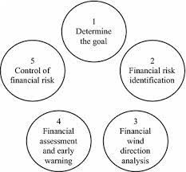

**6. RESULT**

We are Buildingan Application using Node-RED which takes inputs from the user and showcases the predicUI.

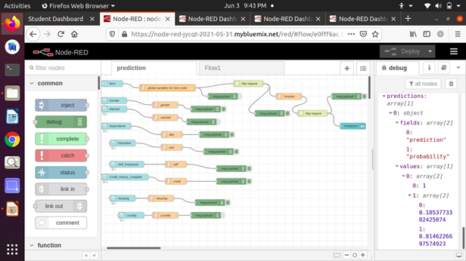

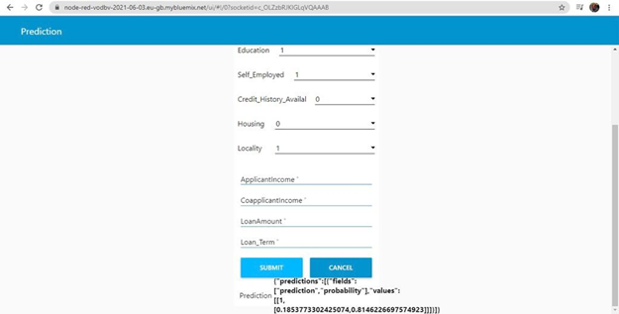

# 7. ADVANTAGES & DISADVANTAGES

**ADVANTAGES**:-

* + Processes unstructured data.
  + Fills humanlimitations.
  + Acts as a decision support system, doesn't replace humans.
  + Improves performance + abilities by giving best available data.
  + Improve and transform customer service.
  + Handle enormous quantities of data.
  + Sustainable Competitive Advantage.

**DISADVANTAGES:**

* + Only in English (Limits areas of use)
  + Seenas disruptive technology
  + Maintenance
  + Doesn't process structured data directly
  + Increasing rate of data, with limitedresources

# 8. APPLICATIONS

* Google's AI-Powered Predictions. ...
* Ridesharing Apps Like Uber and Lyft. ...
* Commercial Flights Use an AI Autopilot.
* Spam Filters.
* Smart Email Categorization.
* Plagiarism Checkers. ...
* Robo-readers. ...
* Mobile Check Deposits.

# 9. CONCLUSION

The conclusion of our project to discusses building a system for creating predictions that can be used in different scenarios. It focuses on predicting fraudulent transactions, which can reduce monetary loss and risk mitigation by building a web application.

Using IBM AutoAI, we automate all of the tasks involved in building predictive models for different requirements. You create a model from a data set that includes the gender, married, dependents, education, self-employed, applicant income, co-applicant income, loan amount, loan term, credit history, housing, and locality.

# 10. FUTURE SCOPE

The fusion of cloud and Artificial Intelligence (AI) can be a source of innovation as well a means to accelerate change. The correlation between AI and the cloud could become a symbiotic relationship, where one technology helps better the other.

# 11. BIBILOGRAPHY

**We use References of previousworks in githup. https://github.com/IBM/predict-fraud-using-auto-ai** We used saw some Reference videos in **You Tube:**

<https://www.youtube.com/watch?v=29qvSy7evgY>